**Question Words Exercises I & II** 102pp to 105pp**.**

**SENAC Morning.**

**Student: Sérgio Felipe Starke.**

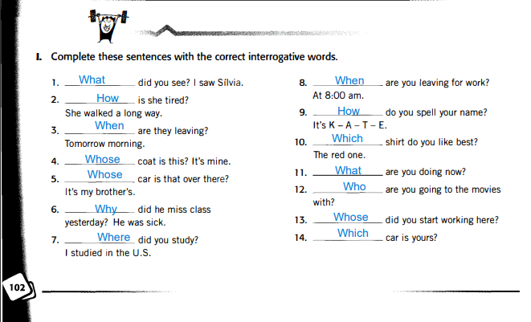

|  |
| --- |
| Note for Correction: |

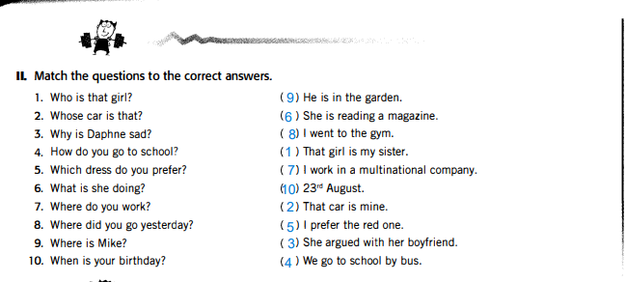

|  |
| --- |
| Note for Correction: |

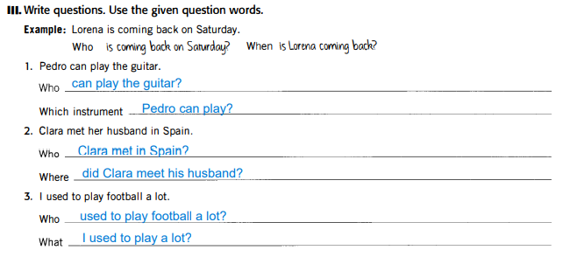

|  |
| --- |
| Note for Correction: |

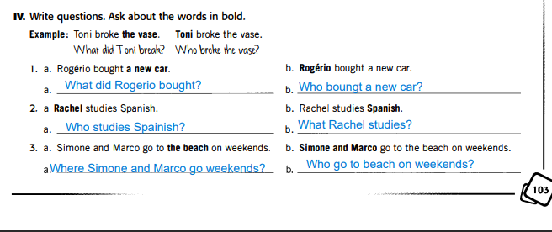

|  |
| --- |
| Note for Correction:  I rectify question 3.a. **Where Simone and Marco go on weekends?** |

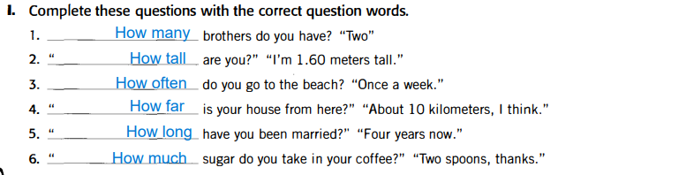

|  |
| --- |
| Note for Correction: |

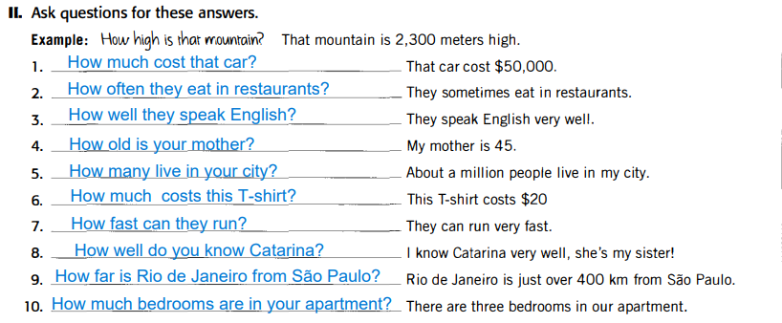

|  |
| --- |
| Note for Correction: |

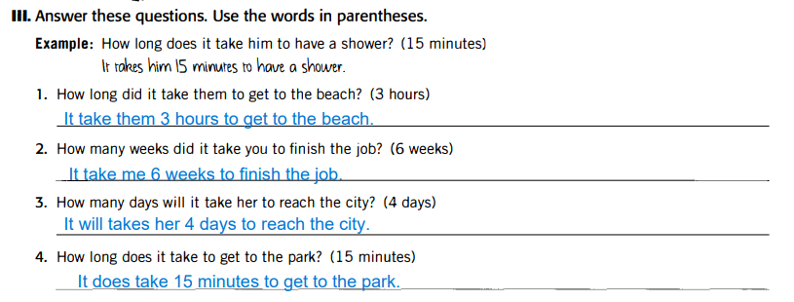

|  |
| --- |
| Note for Correction: |

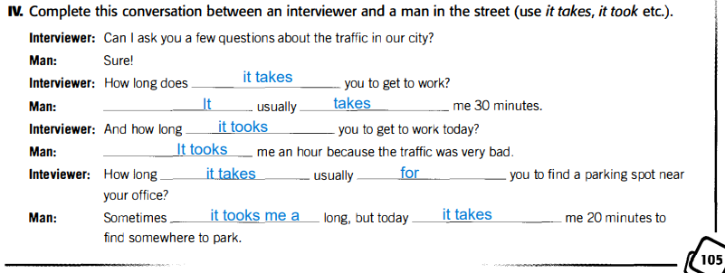

|  |
| --- |
| Note for Correction:  I’m not sure if **Tooks** is right, but it is in third person... |